

Chantal’s W&DSC Head Coach Highlights
October Report 2017
Masters with Kerri-Anne Payne
8th in DIV 2 after round 1 of NAL!!
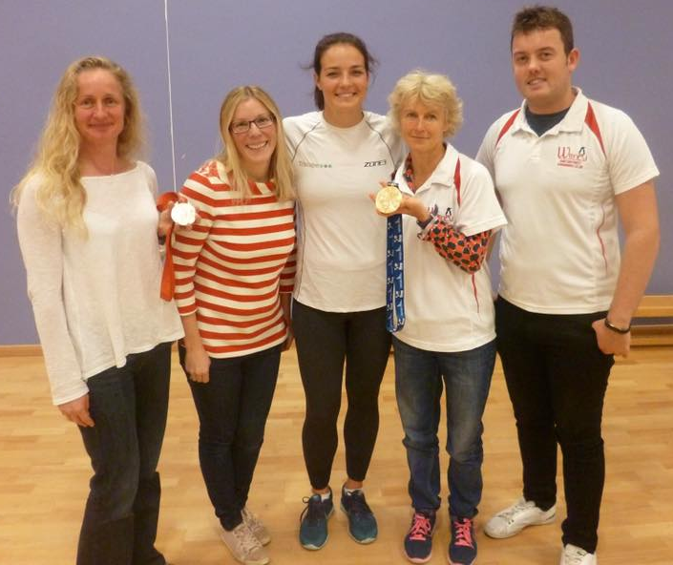
Congratulations to Record Breakers:
Dexter Townsend – 9/u 400m FC
Open 6x50m FC girls relay team – Maddie, Georgia, Lauren, Ella, Rhiannon, Ellie

Swim Camp fun!

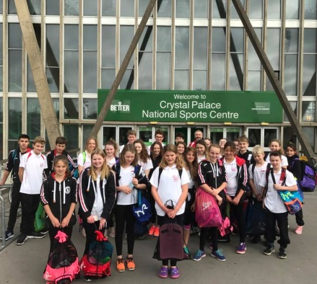
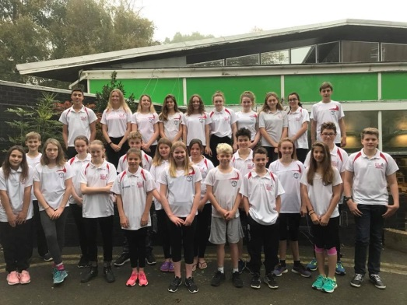

Happy Halloween!!!!


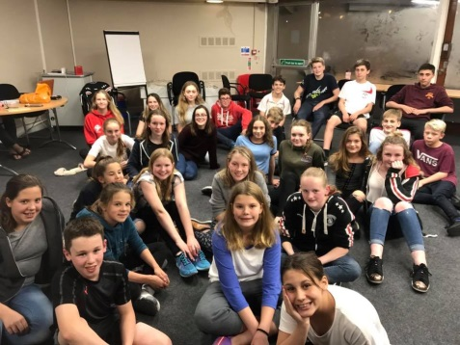
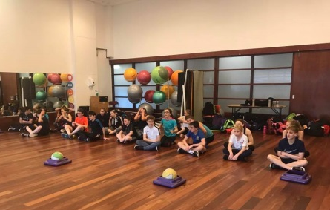

ONB County development day!
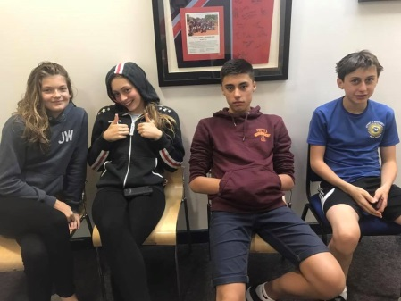

Oxford Development meet 1

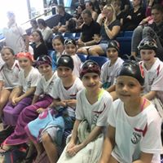
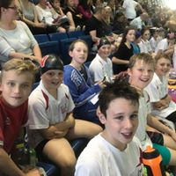

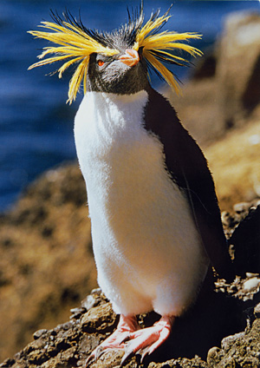

Chantal’s favourite penguin of the month………
ROCKHOPPER! GOOD LUCK at Club championships finals in Nov!
Did you know…..
The fastest penguin is the Gentoo up to 22mph

