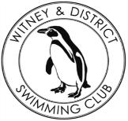
Chantal’s W&DSC Head Coach Highlights Oct Report 18
New October/Nov Club records:
Distance meet - Jess Miller 13/u 1500m FC
NAL RD 1 - Maya T-S - 11/u 50m Brs / Eleanor Perks - 13/u 100m Brs
13/u 4 x 50m Medley relay - Jess, Lucy, Erin and Eleanor
NAL RD 2 Gala - Girls 13/u 4 x 50m Medley Relay – again!
W&DSC distance meet - Jess Miller (13/u 800m FC) and Hugo Jinks (15/u 1500m FC)
Cardiff open meet - Sienna Saunders (11/u 100m Bk), Maya T-S (11/u 100 + 200 Brs), Eleanor Perks (13/u 100m Brs)
Oxford Development meet - Henry Purcell (9/u 200m Bk)

ONB County closing date is Monday 3rd December!

Club championship finals 24/25th November at Carterton LC

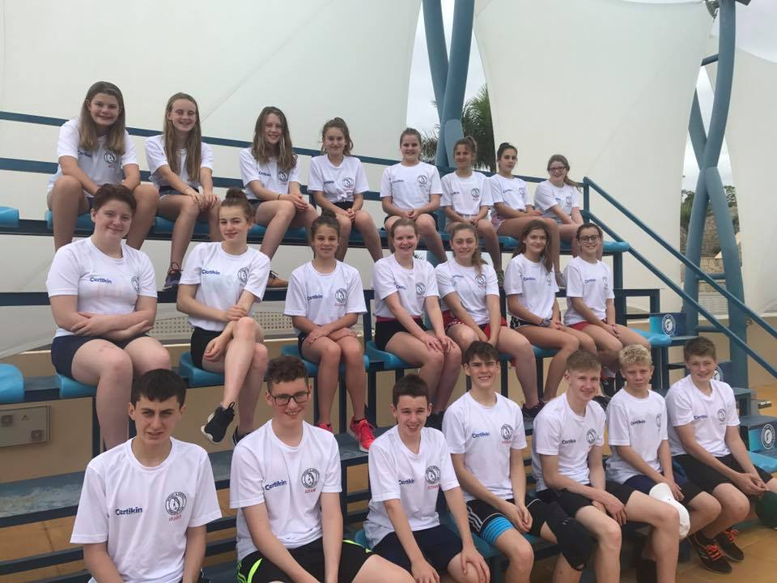
Swim camp 2018
22 Witney swimmers travelled to Tenerife with 4 coaches to do a 7 day training camp – 2 x 2hr pool sessions per day, 2 x 1hr land training sessions per day. Lot of food, games, giggles and a fun day at Siam water park.
Well done to all for their hard work and great behaviour representing W&DSC

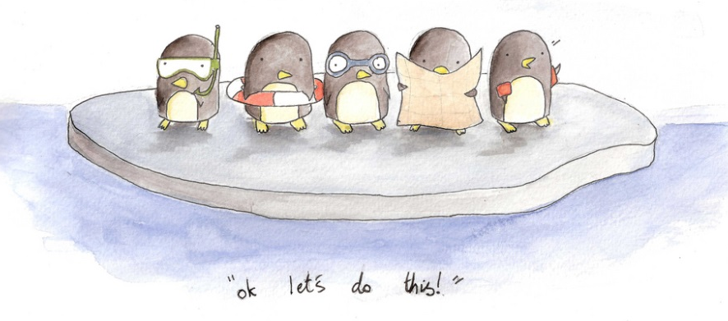
Good luck to Georgia Duff at Scottish Nationals and Ella + Jess at Welsh Nationals.

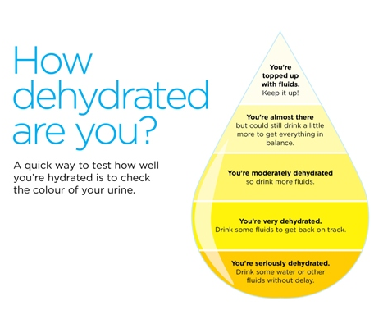
National Arena League success!!
Rd 1 – 3rd = 9th in league
RD 2 – 1st= 5th in league
We are in the final of the National Arena League Div 2 West Midlands League!
Saturday 8th December – Worcester!

