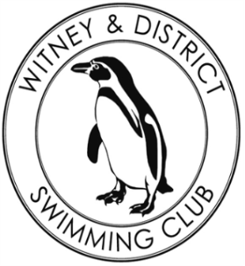
Chantal’s W&DSC Head Coach Highlights
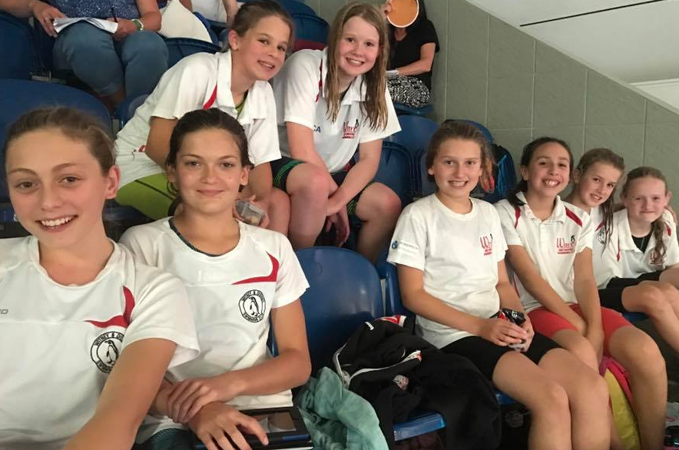
October 2017
Open meet happiness:
Our 2017 – 18 Club Captains:
Rhiannon, Ben, Matthew and Sophie
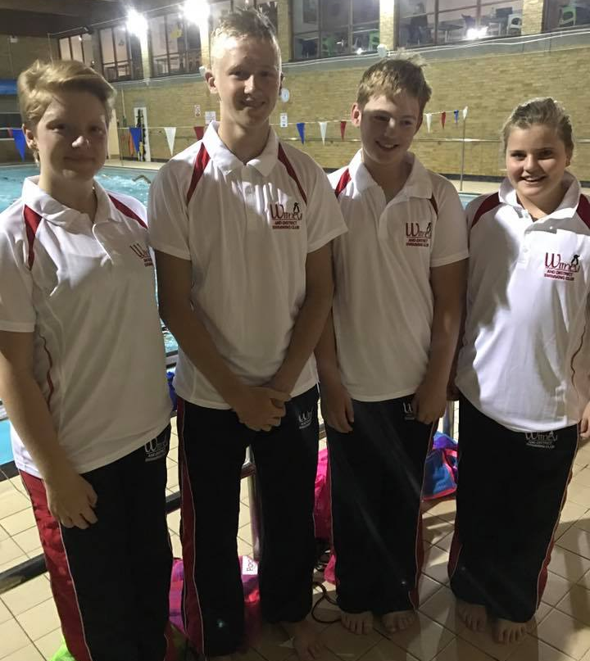
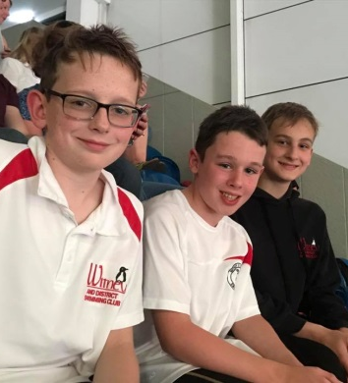

Congratulations to Club Championship Record Breakers:
Georgia Duff – 50 FLY, 50 BK, 100 BK, 100 IM
Lauren Mellings – 200 FC, 200 BK, 400 IM
Ellie Browne – 200 BRS, 400 IM
Camille Duff – 50 FLY. 400 FC, 100 FLY, 200 FLY
Malik Khazir – 50 FC, 50 FLY
Tia Collett – 50 FC, 100 IM
Reuben Coppuck – 100 IM, 50 BRS
Erin Stewart – 50 FLY

2017 MKJL Results:
2nd overall and promoted to div 1 2018!

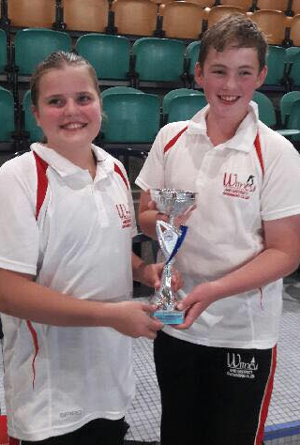
Club Championship fun!

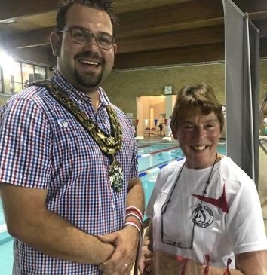
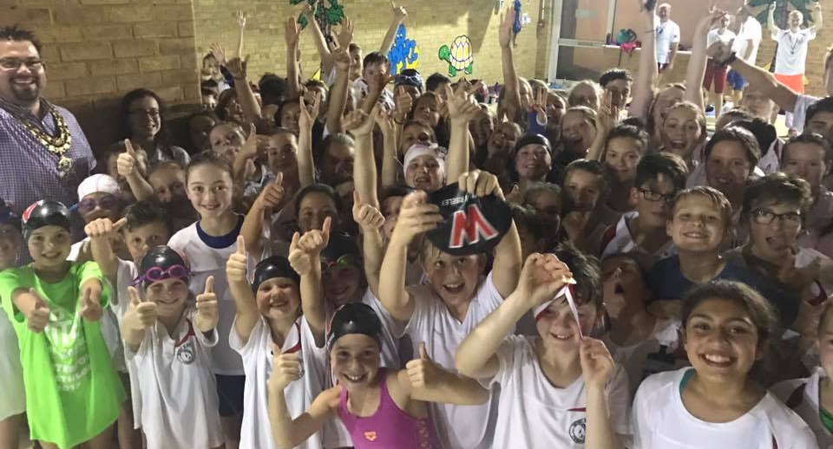

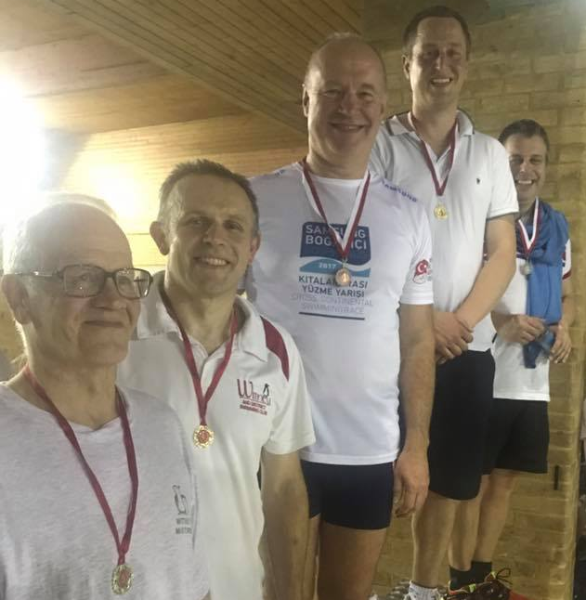
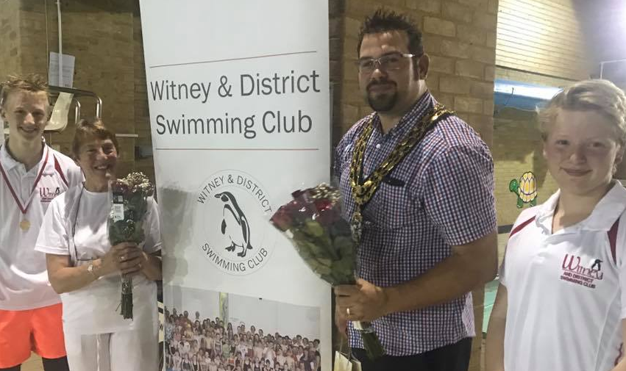

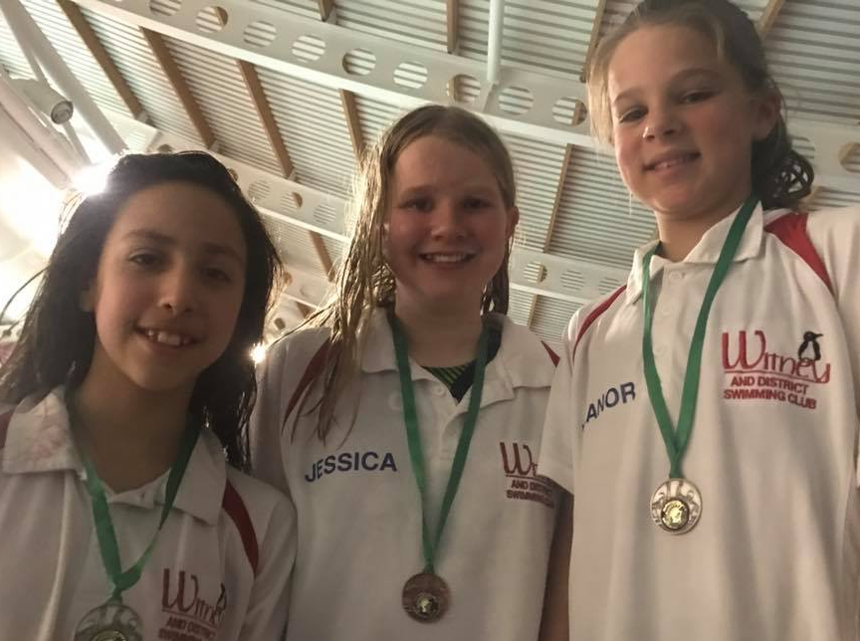
Did you know…..
Swimmers use nearly every muscle in their bodies - more than football!
Elephants can swim an average of 20 miles a day!
Benjamin Franklin invented the lightbulb and fins!

